Name: Muhammad Uzair

Roll No. L1F18BSCS0311

Section - H

Database

Assignment 2

Question 1

(1)

select movie.Mname, mtype.Tname

from movie

inner join Mtype

inner join Movie_type

on Movie.MovieID = Movie_Type.MovieID and Mtype.TypeID = Movie_type.TypeID and Movie.Realease_Date >= '2000-01-01' and Movie.Realease_Date <= '2009-12-31';



(2)

select staff.SName, staff.SDesignation

from staff

inner join booking

on staff.SID = booking.SID

inner join screen_movie

on screen_movie.screen_movie_id = booking.screen_movie_id

inner join movie

on movie.movieid = screen_movie.movieid and movie.mname = 'Avengers';



(3)

select movie.MName

from movie

natural join movie_type

group by movie_type.movieid

having count(movie_type.movieid) > 1;



(4)

select category.catname, movie.mname

from category

left join movie_category

on category.catid = movie_category.catid

inner join movie

on movie.movieid = movie_category.movieid;





(5)

select movie.mname, sum(booking.no_of_seats) as bookings

from movie

inner join screen_movie

on movie.movieid = screen_movie.movieid

inner join booking

on screen_movie.screen_movie_id = booking.screen_movie_id

group by movie.mname;

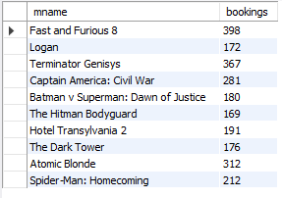

(6)

select category.catname, count(movie.mname)

from movie

inner join movie_category

using(MovieID)

inner join category

using(CatID)

group by category.catname;

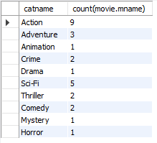

(7)

select distinct movie.mname from movie

inner join movie_type

on play_time > 120

union

select distinct movie.mname from movie

inner join movie_type

on movie.movieid = movie_type.movieid and movie_type.typeid = 2;



(8)

select catname from category

inner join movie_category

on category.catid = movie_category.catid and movie_category.movieid = null;



(9)

select m1.mname as movie1, m2.mname as movie2 from movie as m1

inner join movie as m2

on m1.realease_date = m2.realease_date and m1.movieid <> m2.movieid;



(10)

select movie.mname, sum(booking.no_of_seats) as seats

from movie

inner join screen_movie

on movie.movieid = screen_movie.movieid

inner join booking

on screen_movie.screen_movie_id = booking.screen_movie_id

group by movie.mname

order by seats desc

limit 1;



(11)

select movie.mname, sum(booking.no_of_seats) as bookings

from movie

inner join screen_movie

on movie.movieid = screen_movie.movieid

inner join booking

on screen_movie.screen_movie_id = booking.screen_movie_id

group by movie.mname

order by bookings desc

limit 0,5;

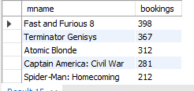

(12)

select movie.mname, sum(booking.no_of_seats) as bookings

from movie

inner join screen_movie

on movie.movieid = screen_movie.movieid

inner join booking

on screen_movie.screen_movie_id = booking.screen_movie_id

group by movie.mname

order by bookings asc

limit 0,5;



(13)

strcmp():

select strcmp("Fast and Furious 8", "Avengers");



Replace();

select replace("Fast and Furious 8", "Furious 8", "Furious Hobbs and Shaw");



Length():

select length(movie.mname) as Name_Length from movie;

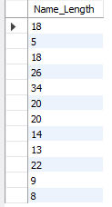

Concat();

select concat(staff.sname,' ',staff.sdesignation) from staff;

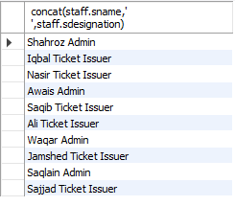

Datediff():

select datediff('2017-04-13', '2017-03-07') as Days_in_between;



Sysdate():

select sysdate();



Curdate():

select curdate();



Date():

select date(realease_date) from movie;



Year():

select mname, year(realease_date) from movie;

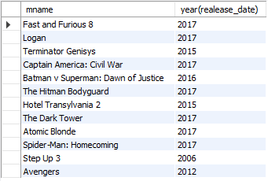

Month():

select mname, month(realease_date) from movie;

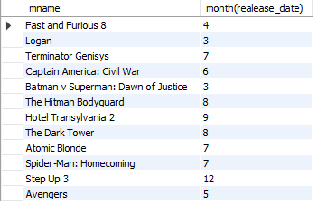

Abs():

select abs(-299.34);



Ceiling():

select ceiling(movieid) from movie;

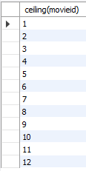

Floor():

select floor(movieid) from movie;

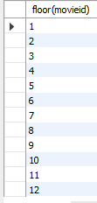

Round():

select round(345.5, 0);



Question 2

(1)

select * from employee

where dno = 4 and salary > 25000 or dno = 5 and salary > 30000;

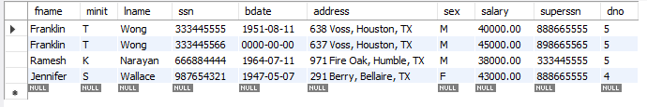

(2)

select distinct e1.ssn from employee as e1

inner join employee as e2

on e1.dno = 5 or e1.ssn = e2.superssn and e2.dno = 5;

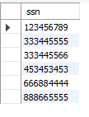

(3)

select e1.ssn from employee as e1

inner join employee as e2

on e1.dno <> 5 and e1.ssn = e2.superssn and e2.dno = 5;



(4)

select project.pname, department.dname

from project

inner join department

on project.dnum = department.dnumber;

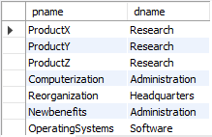

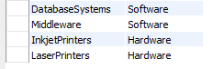

(5)

Select concat(fname,lname) as Fullname

from Employee

where ssn IN (select essn from Works_on, Project where ssn = essn and dno <> dnum and pno = pnumber);

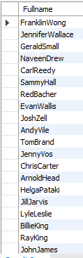



(6)

select avg(salary) from employee

where sex = 'F'

group by sex;



(7)

select concat(fname,lname) as fullname, sex, salary

from employee

where salary > (select avg(salary) from employee where sex = 'F' group by sex);

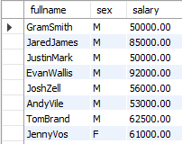

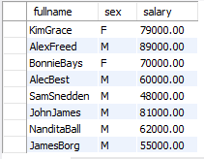

(8)

select department.dname, avg(salary)

from employee

inner join department

on employee.dno = department.dnumber

group by employee.dno;

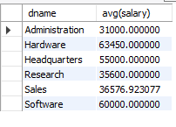

(9)

select concat(employee.fname,employee.lname) as fullname

from employee

where employee.ssn not in (select distinct essn from dependent);

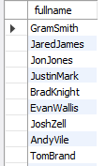



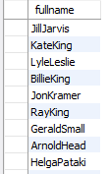

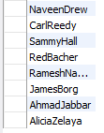

(10)

select concat(fname,lname) as fullname, salary, sum(hours)

from employee

inner join works_on

on works_on.essn = employee.ssn

group by works_on.essn;

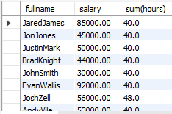

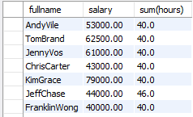

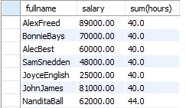

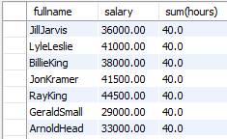

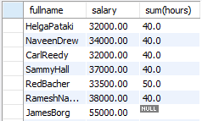



(11)

select concat(fname,lname) as fullname, salary, sum(hours) as total_hours

from employee

inner join works_on

on works_on.essn = employee.ssn

group by works_on.essn

having total_hours < 20.0;

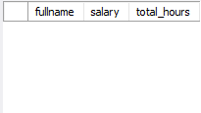

(12)

select concat(fname,lname) as fullname

from employee

inner join department

on employee.ssn = department.mgrssn

inner join dept_locations

on employee.dno = dept_locations.dnumber and dept_locations.dlocation = 'Houston';

